Algebra Unit 3 Test REVIEW Name:______________________________
SpringBoard Period __________ Date _____________

(01) Kerri has typed 300 words for her essay. If she types 45 words per minute, write a function that expresses her total words w written after m minutes?

(02) Super Cell Mobile offers a plan for their cell phones. The cost is $45 for the first 300 minutes and an additional $0.25 for every minute over 300. Joyce wrote the following incorrect piecewise-defined function to express the cost of using 500 minutes.
$C\left(t\right)=\left\{\begin{aligned}45, when 0≤t≤300 \\ 45+0.25t, when t>350\end{aligned}\right.$
Why is the function Jacqueline used incorrect?

(03) George has two jobs. His first job pays according to the piecewise-defined function
$P\left(t\right)=\left\{\begin{aligned}9t, when 0≤t<40 \\ 12.5t-140, when t≥40\end{aligned}\right.$
His second job pays according to the piecewise-defined function
$Q\left(t\right)=\left\{\begin{aligned}12t, when 0≤t<40 \\ 15t-200, when t≥40\end{aligned}\right.$
How much will George make if he works 42 hours in his first job and 13 hours in the second job?

(04) Matt is traveling from Phoenix to the Grand Canyon. He averages 55 mi/h on the 225 mile trip. Write an equation that describes Matt’s distance d from the Grand Canyon h hours after he leaves Phoenix?

(05) Shelley bought a bag of popcorn and a fountain pop for $4. Greg bought 2 bags of popcorn and 3 fountain pops for $10.50. How much does a bag of popcorn and a fountain pop cost?

(06) Eddie rented 4 moves for the weekend. DVDs cost $2 to rent and Blu-ray Discs cost $5 to rent. If Eddie paid $11, write a system of equations can be used to determine x, the number of DVDs rented and y, the number of Blu-ray Discs rented?

(07) Graph the following piecewise-defined function.

f(x) = $\left\{\begin{aligned}-x-7, when-5≤x<-3 \\ x-1, when-3≤x<1 \\ 2x-3, when 1≤x≤2\end{aligned}\right.$
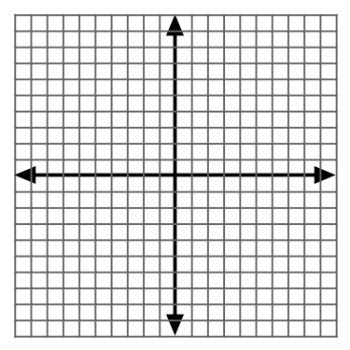

(08) Write the inequality for the graph below.
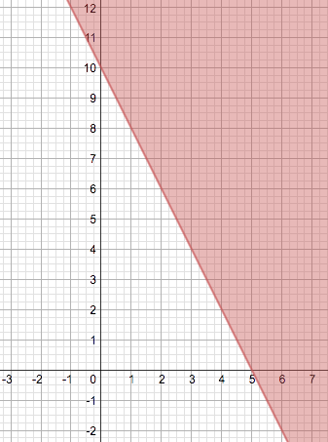

(09) Nathan and Olivia began saving money the same week. The graph below shows the amount of money each of them has saved after x weeks.
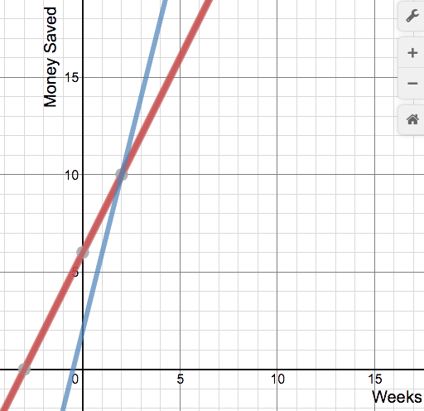

After how many weeks will Nathan and Olivia have the same amount of money saved?

(10) Which point represents the solution of the system of linear equations?
x + 2y = 12
y = 1.5x + 2
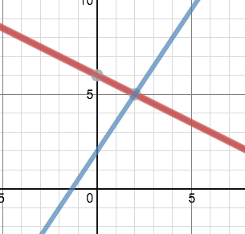

(11) Solve the system of linear equations.
x + y = 16
y = 7x

(12) Solve the system of linear equations.
3x + y = 4
2x – y = 6

(13) The sum of two numbers is 70. One number is ten more than twice the other number. Write a system of equations to represent this problem. Then find the numbers.

(14) Rylee has some $1 bills and some $5 bills. In all, she has 6 bills worth $22. Let x be the number of $1 bills and let y be the number of $5 bills. Write a system of equations to represent the information and use substitution to determine how many bills of each denomination Rylee has.

(15) Write a system of equations that would have infinitely many solutions. What would the graph look
like?

(16) Write a system of equations that would have no solution. What would the graph look like?

(17) Name an ordered pair that is a solution to the given graph below.
Name an ordered pair that is not a solution to the graph below
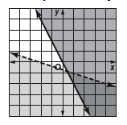

(18) A system of linear equations is graphed. If the graph shows the systems to be dependent and inconsistent, what will the graph look like?

(19) A system of linear equations is graphed. If the graph shows the systems to be independent and inconsistent, what will the graph look like?

(20) Which of the following ordered pairs satisfies both inequalities below?
y + x > 6
2x ≤ y + 8
- (2, 4)
- (6, 2)
- (9, -2)
- (7, 0)

(21) Solve the system of equations using any method.
x + y = 12
2.5x + 7.5y = 50

(22) Determine the number of solutions of the system of linear equations below.
y = 2x + 3
-6x + 3y = -6

(23) Steve and Josh share a car. If the car has 14 gallons of gas in it and it gets 18 gallons per gallon, write an inequality shows the distance s that Steve can drive and the distance j that Josh can drive before they run out of gas?

(24) Adam took a trip that required him to travel by car and by airplane. He figured out that it cost about $0.18 per mile traveling in the car and about $0.42 per mile in the airplane. If he spent $189.60 and traveled a total of 520 miles, how many miles did he drive?

(25) Which system of inequalities has the solution region shown in the graph below?
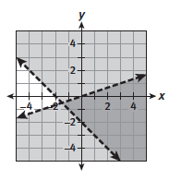
A. 3y < x B. 3y < x C. 3y > x D. 3y > x
X + y > 2 x + y > -2 x + y > 2 x + y > -2

(26) The graph shows the solution of a system of inequalities. Which statement is true?
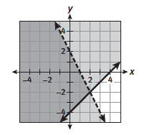
- (2, -2) is a solution
- The origin is not a solution
- Any ordered pair with a negative x-coordinate is a solution.
- (2, -4) is not a solution.

