Algebra Unit 4 REVIEW Name:______________________________

SpringBoard Period __________ Date _____________

(01) A square has a side length of (3x + 2) inches. Write at least two equivalent expressions that represent the area, in square inches, of this square.

(02) Write at least two equivalent expressions to.

(03) Write an expression that is equivalent to $x^{2}-36$.

(04) Write an expression that is equivalent to ${(3x}^{2}-4x+5)$ + $(x^{2}+3x-7)$?

(05) Write an expression equivalent to $16-4x^{2}$?

(06) Simplify -2

(07) Simplify the expression $\frac{20a^{3}bc^{6}}{4ab^{3}c^{4}}$

(08) What is the difference of 12x + 25y and 6x – 8y?

(09) Write the factors of $x^{2}-x-30$?

(10) A soda company wants to introduce a new family size soda can that holds more soda than their traditional can, so they have decided to change the size of the cylinder– shaped can their soda is packaged in.

The volume of the can that holds the soda is represented by the expression, h(πr2) where r is the radius of the can, and h is the height of the can.

Describe what will happen to the can if the soda company increases the length of the radius of the can?

(11) Simplify the expression 

(12) What is the sum: ${(4x}^{2}-9x+4)$ + (2x – 4)

(13) What is the difference? (x2 + 3x − 7) − (3x2 − x + 9)

(14) What is the product? (x2 + 4) (2x − 6)

(15) Simplify: (5x − 2)2

(16) What is the area of the rectangle, in square units?

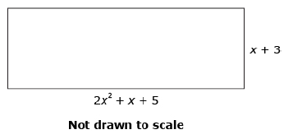

2x2 + 3x + 1

x + 4

(17) What is the greatest common factor of the terms in the polynomial 36ab5 + 48ab3 + 60ab2?

(18) Factor x2 − 24x + 144

(19) Factor 4x2 − 81

(20) Factor x2 + 7x − 8

(21) Which are factors of the trinomial ? List ***all*** that apply.

3x2 + 22x + 7

(22) Given the polynomial , identify the number of terms, the coefficients, the constant term, and the degree of the polynomial.

(23) Simplify ?

(24) Xavier wants to install a pool in his backyard. The pool will have a width of 4x and length of 7x-2. The yard has a width of 6x+2 and length 16x-5. What is the area of the yard that is left after the pool is installed?

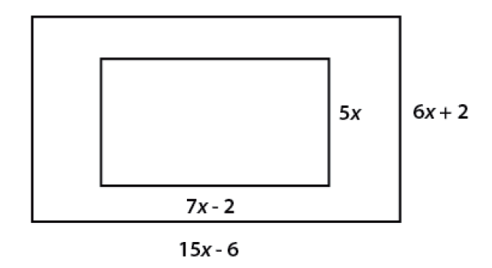

16x - 5

4x

(25) A square room has an area of 4x2 + 20x + 25. What is the length of each of the sides?

(26) A rectangular pool table has an area of 6x2 - 11x - 2. The length of one side is x-2. What is the length of the other side?

(27) Find the area of the rectangle.



x - 5

(28) Factor 9x2 - 100?

(29) Factor 2x2-32

(30) Factor 3x2 + 15x + 18