Algebra Unit 4 Name: ___________________________________
Review Embedded Assessment #3 Period__________ Date_____________________

Polynomial Operations: MEASURING UP
Employees at Ship-It-Quik must perform computations involving volume and surface area. As part of the job application, potential employees must take a test that involves surface area, volume, and algebraic skills.
1. The surface area of a figure is the total area of all faces. The areas of the faces of a rectangular prism are shown. The surface area of this prism is 22x² + 10x + 12. Complete the first part of the job application by finding the area of the missing face.
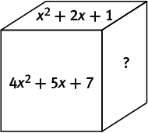

The formula for the volume of a rectangular prism is V = lwh, where l, w, and h are length, width, and height, respectively. The formula for the surface area is SA = 2lw + 2wh + 2lh.
2. Complete the second part of the job application by verifying whether or not the following computations are correct. Explain your reasoning by showing your work.
Volume: 2x³ + 32x² + 120x
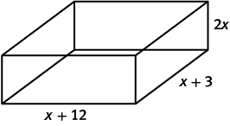

x + 6
x + 10

Surface Area: 5x² + 48x + 60

3. Complete the final part of the job application by writing an expression for the volume of a cylinder with radius 4xy² and height 3xy. Use the formula V = πr²h where r is the radius and h is the height. Simplify your answer as much as possible.

