Algebra Unit 3 Name: ___________________________________

Review Embedded Assessment #2 Period__________ Date_____________________

**Systems of Equations and Inequalities**

1. Kay and her brother Nate are each saving their allowance. Kay has saved five more than three times what Nate has saved. Their combined savings is $23.

a. Write a system to represent this situation. Define each variable that you use.

b. Solve the system using substitution or elimination to determine amount each person has saved. Justify the reasonableness of your solution.

c. Solve the system by graphing. Explain the solution..

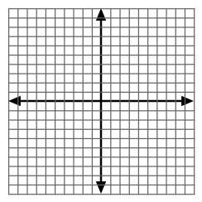

2. Kay and Nate will save their money by putting dimes, quarters and dollar bills in a piggy bank. Their savings is described in the table.

|  |  |  |  |
| --- | --- | --- | --- |
|  | Dimes | Quarters | Dollars |
| Kay’s savings | 15 | 10 | 19 |
| Nate’s savings | 5 | 6 | 4 |

a. Their size of their piggy banks limit both the dimes and quarters be 16 or less and the number of dimes plus the number of quarters be no more than 24. Write a system of inequalities to represent this situation.

b. Graph the system from part a to show all of the possible values of dimes and quarters that the piggy banks could have.



c. Is either savings unacceptable? Justify your answer using the table or the graph