Core 8 Unit 3 Name: ___________________________________
Review Embedded Assessment #4 Period__________ Date_____________________

The Pythagorean Theorem: Camp Euclid
Steve is spending part of his summer vacation at Camp Euclid with some of his friends. On the first day of camp, they must pass an open-water swimming test to be allowed to use the canoes, kayaks, and personal watercraft. Steve and his friends must be able to swim across the river that they will be boating on. The river is 24 meters wide. On the day of the test, Steve begins on one bank and tries to swim directly across the river to the point on the opposite bank where his counselor is waiting. Because the river has a slight current, Steve ends up 28 meters downstream from his counselor.
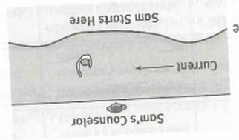
Steve’s Counselor
1) Label the diagram for the
problem situation.

Steve starts here

2) How far did Steve actually swim? Justify your answer.

3) Steve's friend Adam started at the same spot but swam 40 meters. How far downstream was Adam from their counselor when he arrived at the opposite bank? Justify your answer.

In a lake fed by the river, a triangular area marked with buoys is roped off for swimming during free time at camp. The distances between each pair of buoys are 50 meters, 60 meters, and 70 meters.
4) Draw and label a diagram for the problem situation.

5) Is the swimming area a right triangle? Justify your answer.

6) Find the missing side length in each of the following triangles. Show all your work. Round to the nearest hundredth if necessary.
36
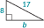
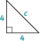
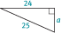
(A) (B) (C)
51
24
5
45

5

7) Determine which of the following sets of triangle side lengths form right triangles. Justify each response.
(A) 16, 30, 34 (B) 10, 11, 21 (C) $\frac{6}{5}$ , $\frac{8}{5}$ , $\frac{10}{5}$

8) After the swimming test, Alex makes his way back to camp. On a coordinate plane, Adam is at the point (−5, 4) and camp is at the point (3, −1). What is the shortest distance Adam will have to travel to get back to camp? Assume each unit of the coordinate plane represents one kilometer.

