Core 8 Unit 3 Name: ___________________________________
Embedded Assessment #3 (QUIZ) Period__________ Date_____________________

Similarity and Dilations: BUSINESS AS USUAL

Liz is a commercial artist working for Business as Usual. The company specializes in small-business public relations. Liz creates appealing logos for client companies. In fact, she helped create the logo for her company.
Business As Usual will use its logo in different sizes, with each design including a triangle similar to the one shown.
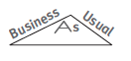
1. The advertisement and stationery letterhead–size logos are shown below with the measurements of some of the side lengths. Determine the missing measures of the sides.

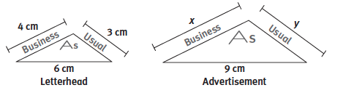

2. To create the triangles in the design, Liz wants to determine the measure of each angle in the designs. The advertisement logo is shown below including the measures of two of its angles. The business card logo will
be similar to the advertisement so that $∆$BAU $\sim$ $∆$CRD. Determine the measure of each angle.
a. m<C =
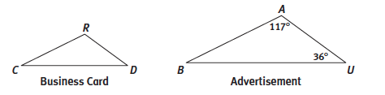
b. m<R =
c. m<D =

Liz tries to incorporate triangles and quadrilaterals into many of the logos she designs for her clients. She begins her layout by laying it out on a coordinate plane.
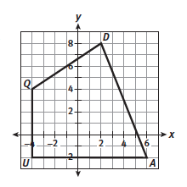

3. Quadrilateral QUAD is shown.
a. Quadrilateral Q’U’A’D’ is a dilation of QUAD
with scale factor 1/2 . List the coordinates of
Q’U’A’D’ and sketch the graph on a coordinate
plane.

Q’ ( ______, ______ )
U’ ( ______, ______ )
A’ ( ______, ______ )
D’ ( ______, ______ )

b. Determine the ratio of the perimeter of Q’U’A’D’
to the perimeter of QUAD.

c. Determine the ratio of the area of Q’U’A’D’ to the area of QUAD.

4. The coordinates of $∆$ABC are A(0, 8), B(5, −2), and C(−4, −2), and the coordinates of $∆$DEF are
D(0, 4), E(3, −1), and F(−2, −1). Determine whether or not $∆$ABC is similar to $∆$DEF.
Defend your answer.
